Name:

### Score: out of

# Baldivis Secondary College

# Year 11 Mathematics Methods

# Test 8 2020

# Introduction to Calculus

**22**

**Non-Calculator Section (No calculator, no notes, formula sheet is provided)**

**Time: 25 minutes Marks: 22 marks**

1. [2,2,2 = 6 marks]

Find the derivative of the following functions. Express with positive indices.

1. y =  b) y =  c) y = 
2. [4 marks]

Find the equation of the tangent line to the curve y =  at the point (1,2).

1. [4 marks]

Using first principles, = , show that the derivative of y = 3x2 is 6x.

1. [4,1,3 = 8 marks]

Consider the cubic function  over the domain -1 ≤ x ≤ 4

1. Use calculus techniques to find the location and nature of the stationary points.
2. Find the x intercepts
3. Graph the function over the given interval

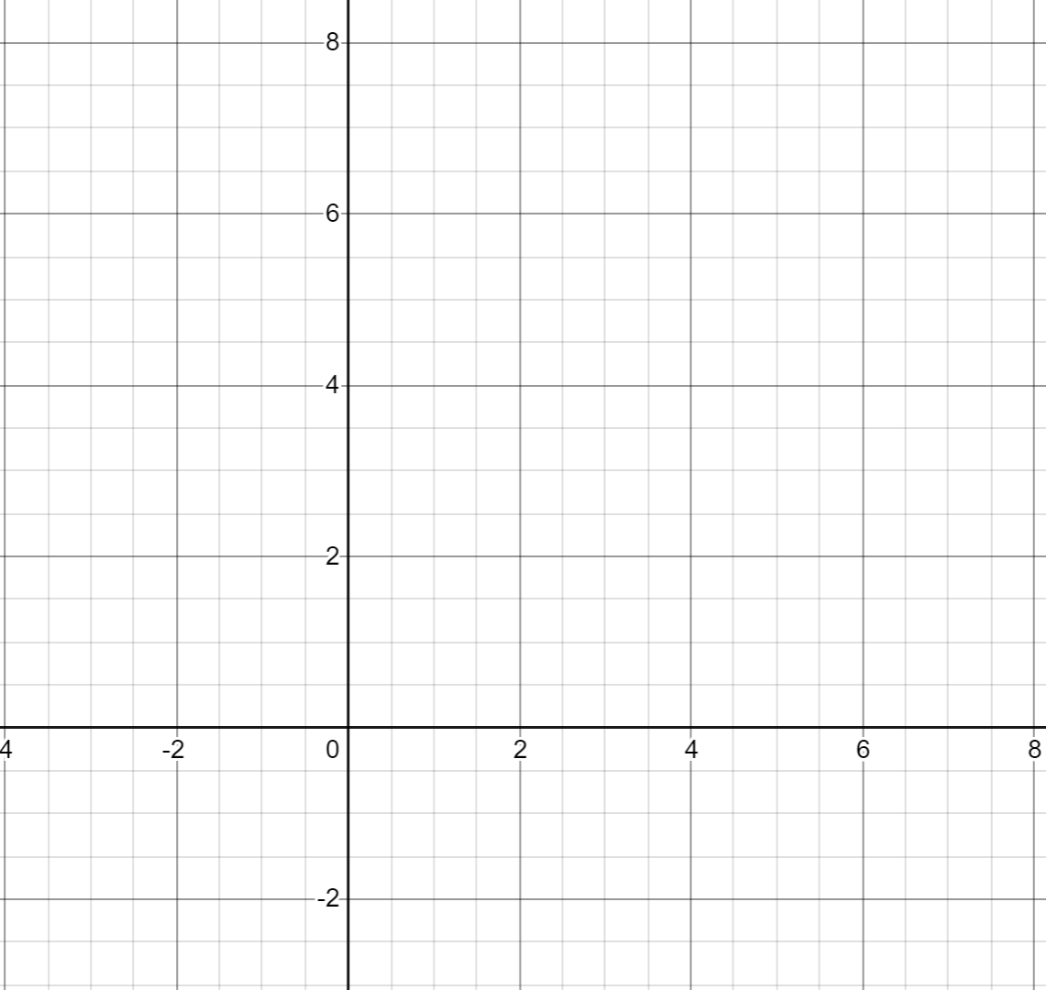

END OF SECTION 1

# Baldivis Secondary College

# Year 11 Mathematics Methods

# Test 8 2020

# Introduction to Calculus

Name:

### Score: out of

**26**

**Calculator Section (Calculators and 1 page (A4) of notes permitted, formula is sheet provided)**

**Time: 30 minutes Marks: 26 marks**

7. [2, 4, 1 = 7 marks]

1. Determine the x-intercepts of the function **y = x2 – 5x – 24**
2. Hence, determine the rules for the lines that are tangent to the curve **y = x2 – 5x – 24** where it crosses the x –axis.
3. Find where these tangent lines meet.

8. [1,1,2,2,3 = 9 marks]

A bullet is fired upwards. After t seconds the height of the bullet is found from the rule

H(t) = 150t – 4.9t2 + 2 where t is measured in seconds and H in metres.

1. Find the height of the bullet after 5 seconds.

The speed of the bullet is the instantaneous rate of change of the height of the bullet.

1. Find a rule for the speed of the bullet at any time t.
2. Find the speed of the bullet after 5 seconds.
3. Find the maximum height of the bullet, to the nearest metre. Indicate your method.
4. Determine the bullet’s speed as it hits the ground, on the way down, to 2 decimal places.

9. [1,1,2,2 = 6 marks]

A sketch of f(x) =  has been provided below.

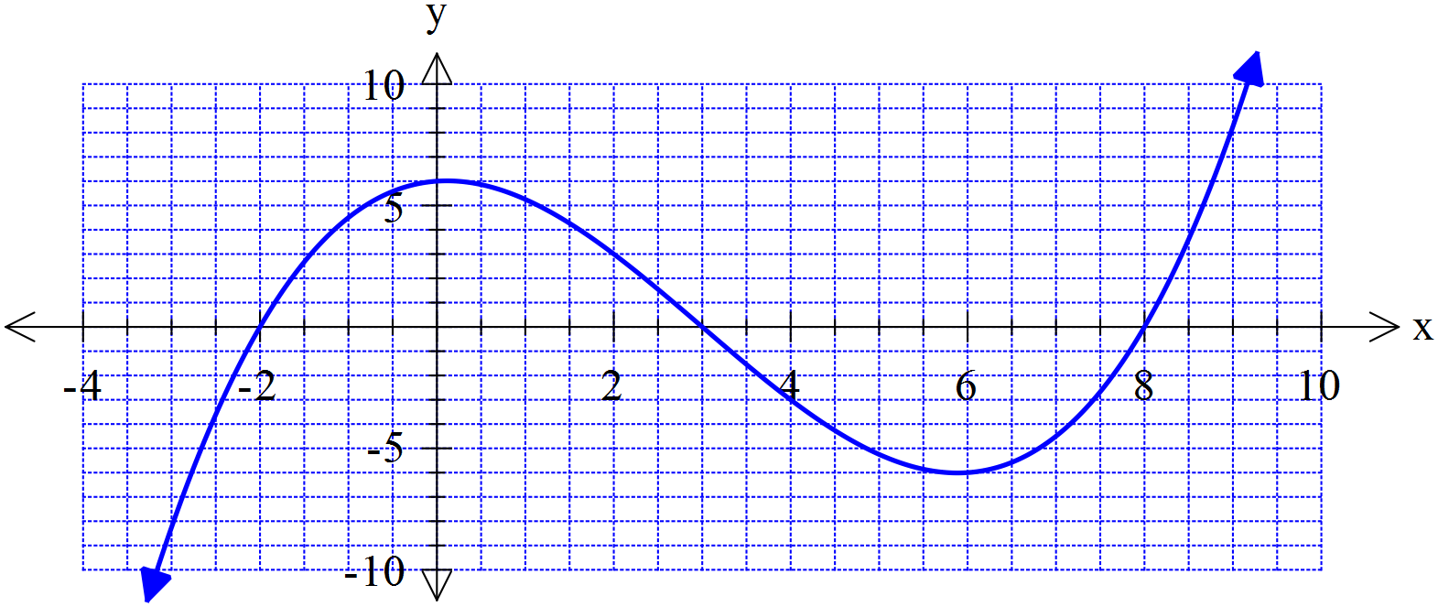

1. What is the average (mean) of the two positive roots of f(x)?
2. On the graph above sketch a tangent line to the curve for the value of x that you calculated in part (a).
3. Find the rule for this tangent line you drew above, that goes through the point where the x-value

Is the average of the two positive roots. You may use your Class Pad.

A student has speculated that the tangent line to the curve at the average of two roots also intersects with the third root.

1. Use your answer from part c to show whether this statement is true or false for f(x).

Does this example support the student’s speculation or not? Discuss.

10. [4 marks]

The function y = x3 + ax + b has a local minimum point at (2,3).

Use differentiation to find the values of a and b.

END OF SECTION 2